Android Notes Application

COMP_C_33_Vikrant Singh
COMP_B_71_ Ananya Singh
COMP_C_23_ Rajan Shukla
COMP_C_<ROLL No>_<NAME>
B.E. Third Year in Computer Engineering
Thakur College of Engineering and Technology
Mumbai, India
examplemail@gmail.com

Abstract— Taking a note is the process of capturing information from a source or event. Many apps have their own unique features, storage, editing, and sharing capabilities, and so on, for the user to see which note-taking app will work best for their needs. Notes apps (also called note-taking apps) allow students to save all their notes and essential digital information. The Android Notes app is an Android-based application that is built in Java. A completely native app, using the latest features of the Android platform to provide the best user experience. It can be used to store important notes, daily activities, etc.

Keywords: Android, Notes, Scanlibrary, Scanner, Room Database, Sqlite, Java.

Introduction
The Android Notes Application aims to address the daily problem of taking notes at appropriate times when the event is fast paced, and you do not have time to pull out your pen and paper.
Taking a note is the process of taking information from a source or event. This often takes the form of writing, snapping, abbreviating, scanning, labelling, clarifying, and defining. Users may type on mobile devices just like they would on paper, with note-taking apps.
This is an Android-based application that was developed in Java. This is a completely native application, using the latest features of the Android platform to provide the best user experience. It can be used to store important notes, daily activities, etc. It uses the device’s local storage as a backend storage support to store user data.
The Notes app is an application designed for storing important information and notes. It also includes creation,
storage, sharing, retrieval, and editing of notes. This app can be used to store all notes and information digitally and helps to complete the written process digitally to save a lot of time.

- LITERATURE REVIEW

Notetaking provides many edges on the far side that record of what was given during a lecture or category activity. Effective notetaking:

->Keeps you alert. Notetaking keeps your body active and concerned and helps you avoid feelings of temporary state or distraction.
->Engages your mind. Listening fastidiously and deciding what to incorporate in notes keeps your mind actively attached what you hear.
->Emphasizes and organizes data. As you're taking notes, you’ll opt for and highlight the key concepts you hear, distinguishing the structure of a category presentation. You’ll even be ready to indicate the supporting points of a presentation, creating study and understanding easier once category. Such organized notes additionally build it easier for you to link schoolroom learning to textbook readings.
->Creates a condensed record for study. a collection of curt, well-organized notes from every category session offers you what you wish for study, learning, and review once category.

REFERENCE:

Austin Community College - "Benefits of notetaking?"

The Notes app lets you lock any note that you want to keep private from anyone else that might use your device. Most users rely on it as some sort of digital post-it. Users have continuously found ways in which to store vital bits of their awareness. This new thanks to get it on is a component of our general cultural shift towards recording expertise electronically and not by pen and paper.

- EXPERIMENTAL SETUP

For this project, we have used Android Studio, Java SDK, and Room Database for storage support to store user data. Given below is the short information of everything we have used in the project.
- Android Studio: Android Studio is Google's official integrated development platform (IDE) for the
Android operating system, built on JetBrains' IntelliJ IDEA software and specifically for the Android upgrade.
available for download on Windows, macOS, and Linux-based application systems. It replaces Eclipse Android Development Tools (ADT) as the main IDE for Android application development.
- Java SDK: "Java SDK" stands for Java Software Development Kit. It is a software development kit for developing software in Java. It is one of three technology packages used by Java, namely JVM, JRE, and JDK.
The JDK contains a set of development tools that help to develop Java-based software. There are several versions, but Java 8 is the most widely used. SDK tools include libraries, combinations, debuggers, processes,
APIs, code samples, guidelines, etc. SDKs are varied; they have different kinds of platforms.
- Room Database: The Room persistence library provides an abstraction layer over SQLite to allow fluent database access while harnessing the full power of SQLite. In particular, Room provides the following benefits:
  - Compile-time verification of SQL queries.
  - Convenience annotations that minimize repetitive and error-prone boilerplate code.
  - Streamlined database migration paths.
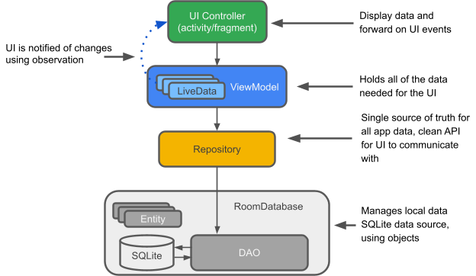

- System requirements:
OS: Windows/Mac/Linux
Android Studio: 2020.3.1 version or above
Java: Java JDK 8 or above
Ram: 8 GB RAM or more
Disk space: 4-8 GB of available disk space

- MODELING AND ANALYSIS

- Data flow diagram

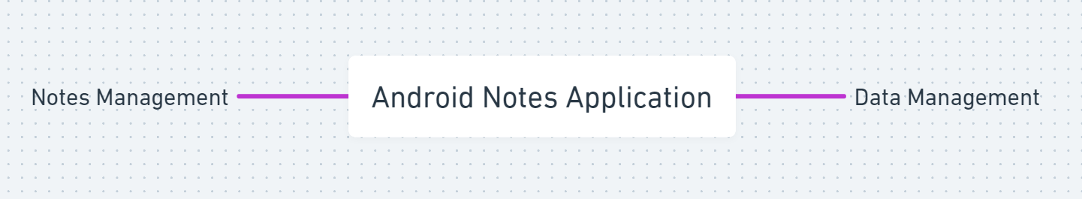

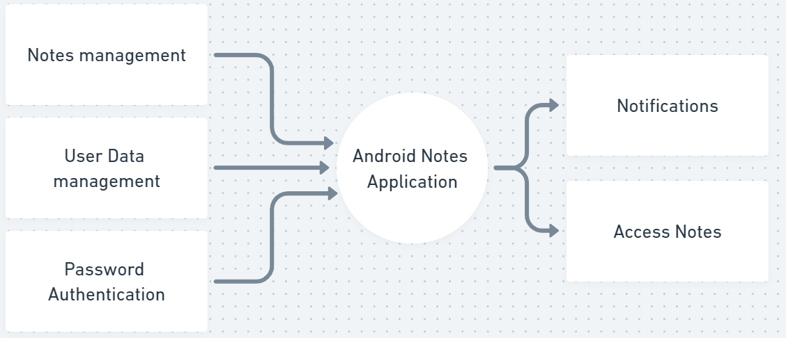

- Use Case Diagram

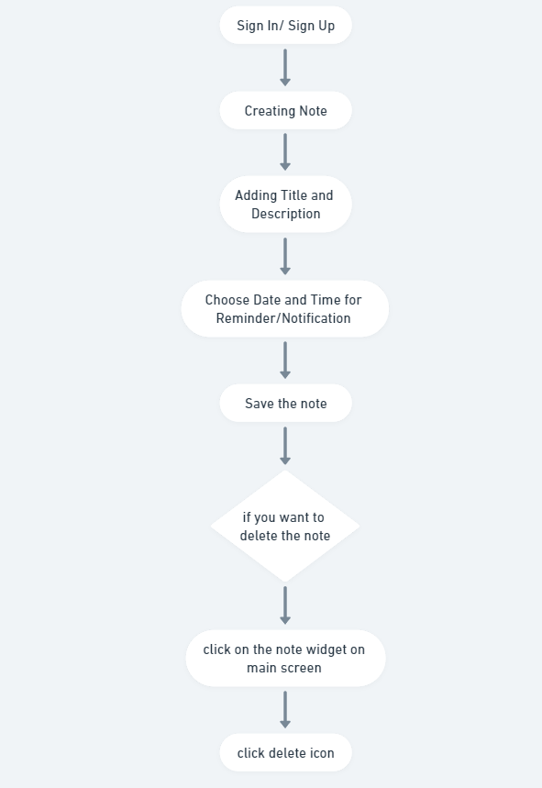

- Project Architecture Flowchart:

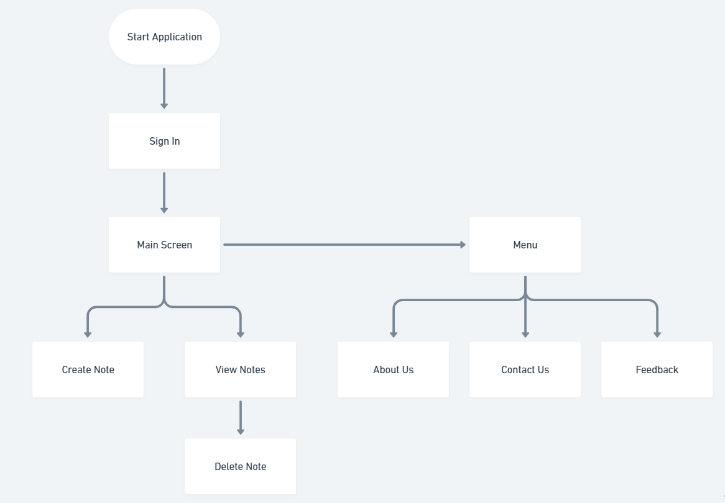

- Project Architecture Algorithm:

1) Open application
2) Sign In
3) Home Screen
a. View already added notes
1. open, view and delete
b. Create new note
1. Add title, description, date, time and save
4) Menu
a. About Us
b. Contact Us
c. Feedback

- USER INTERFACE DESIGN

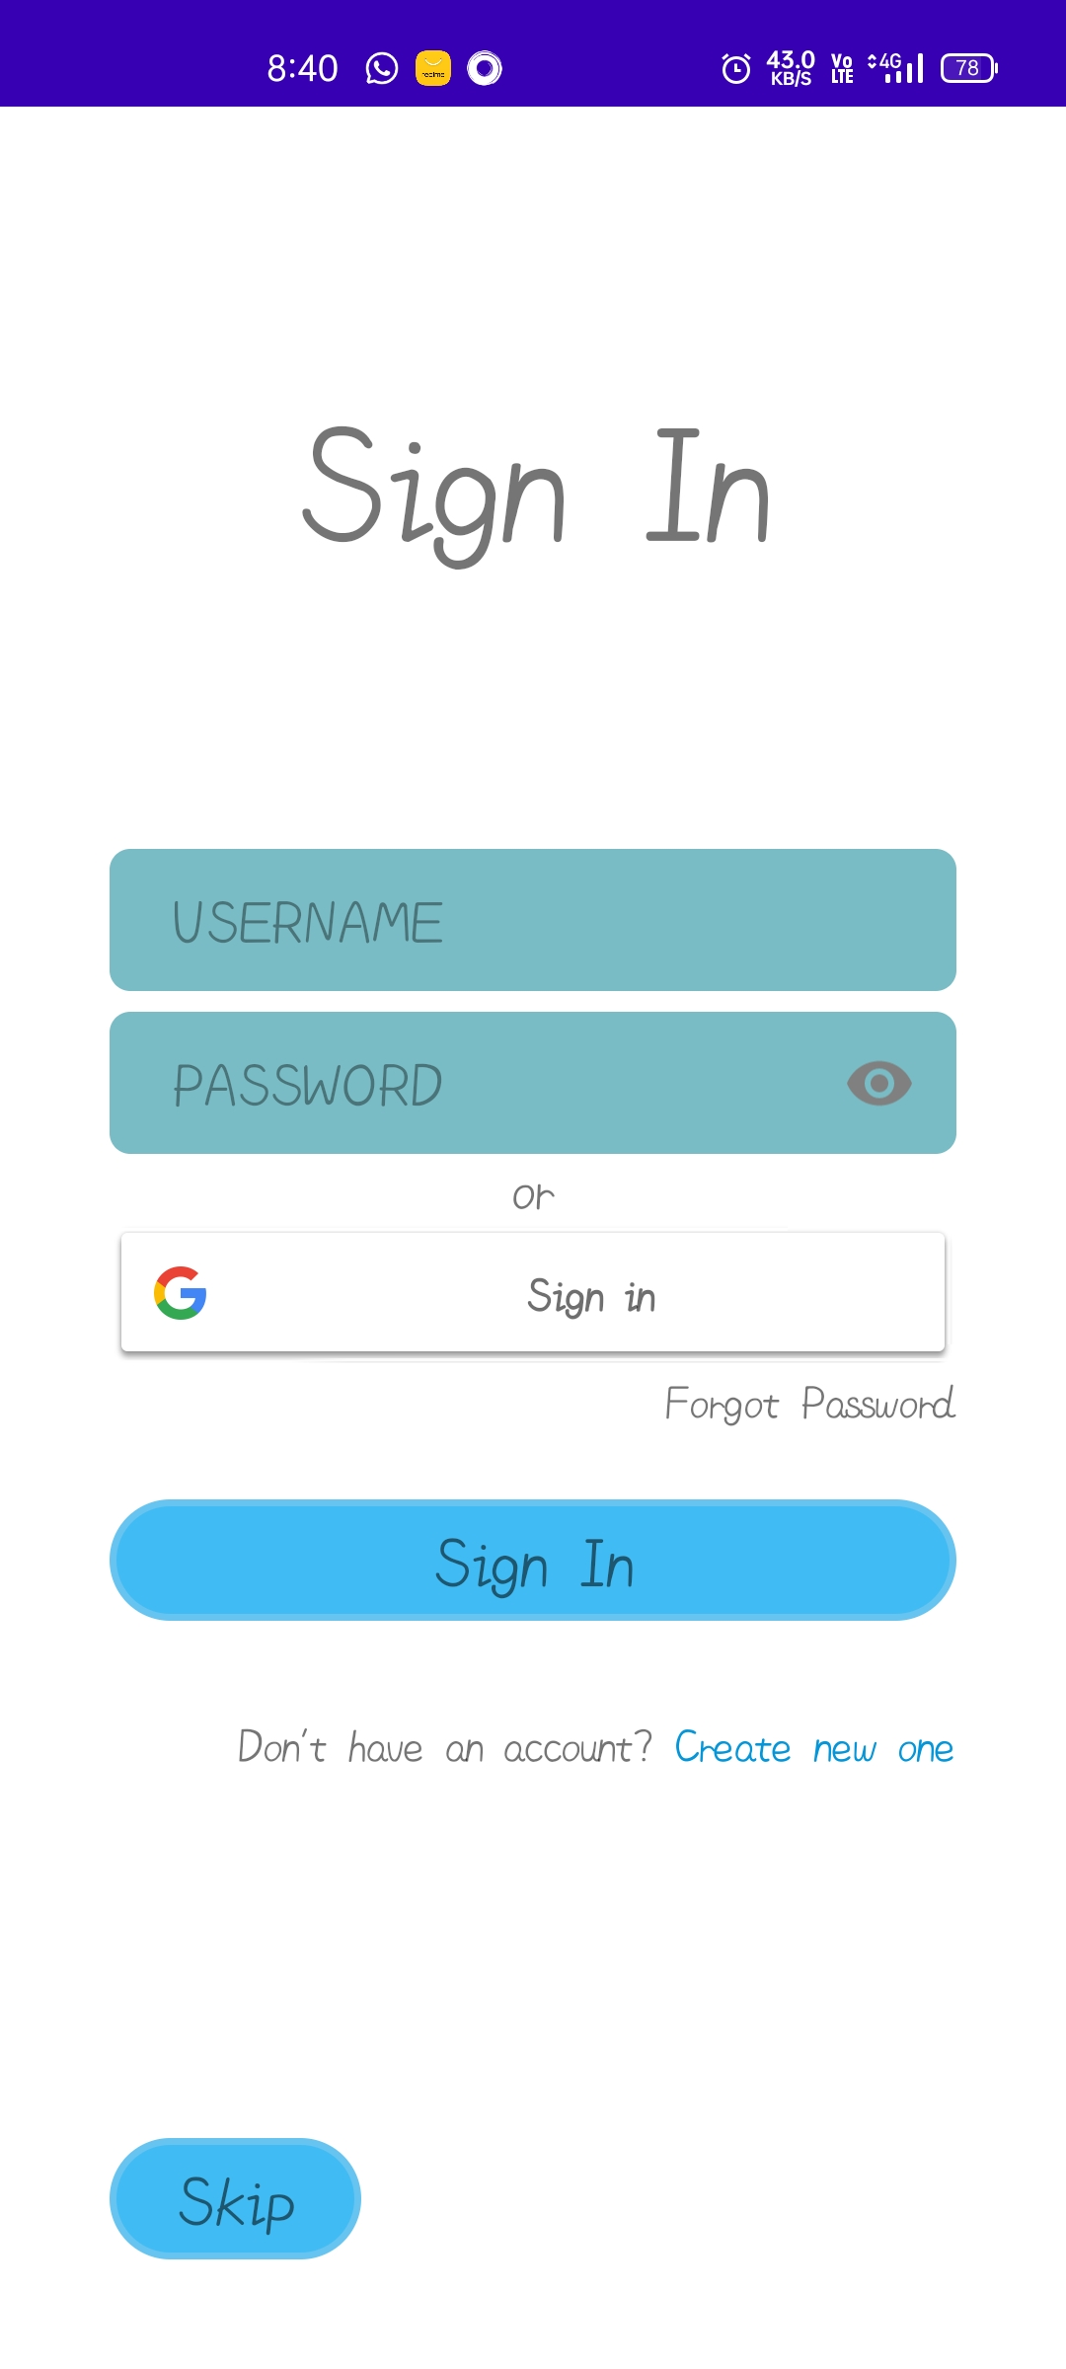

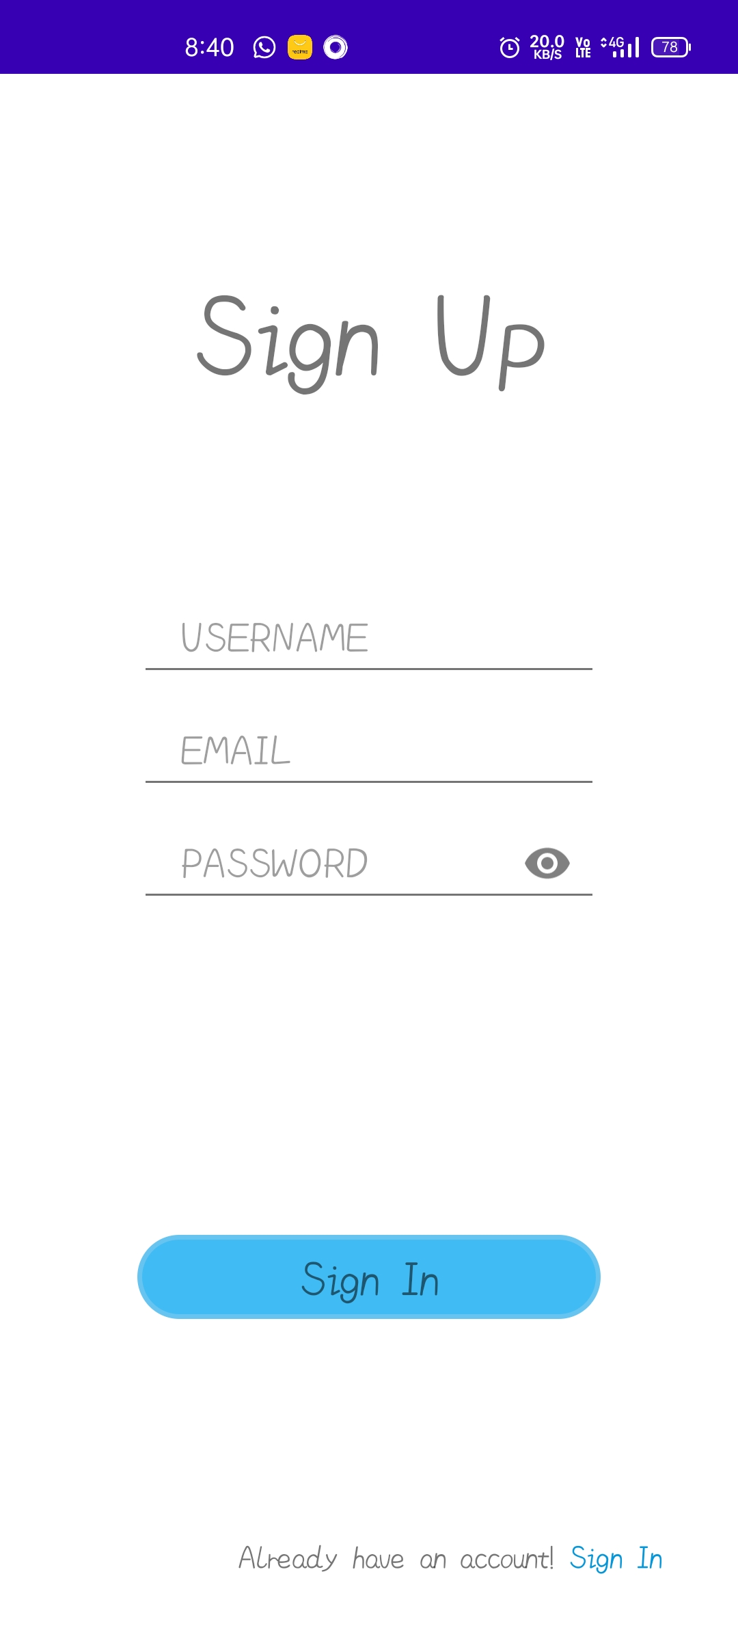

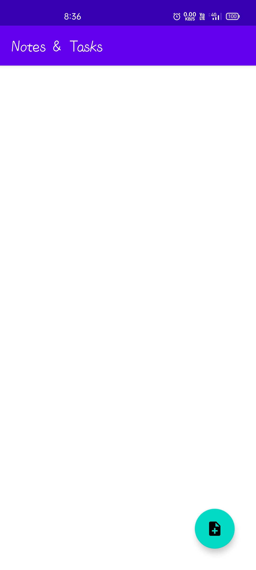
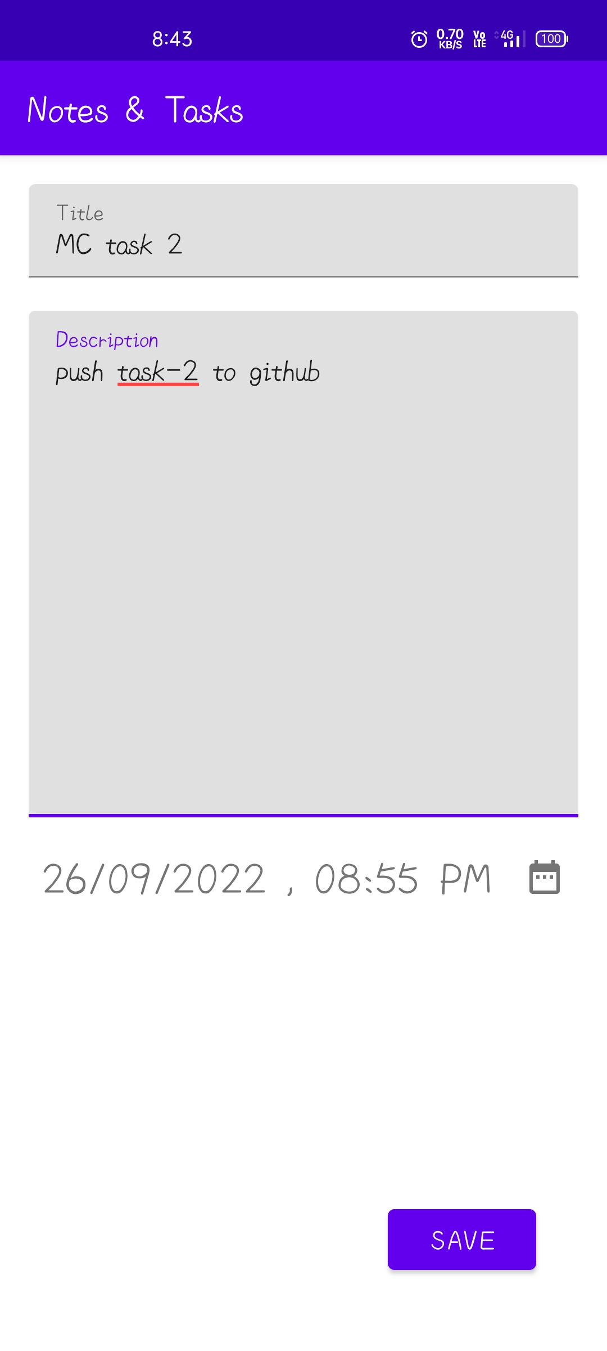

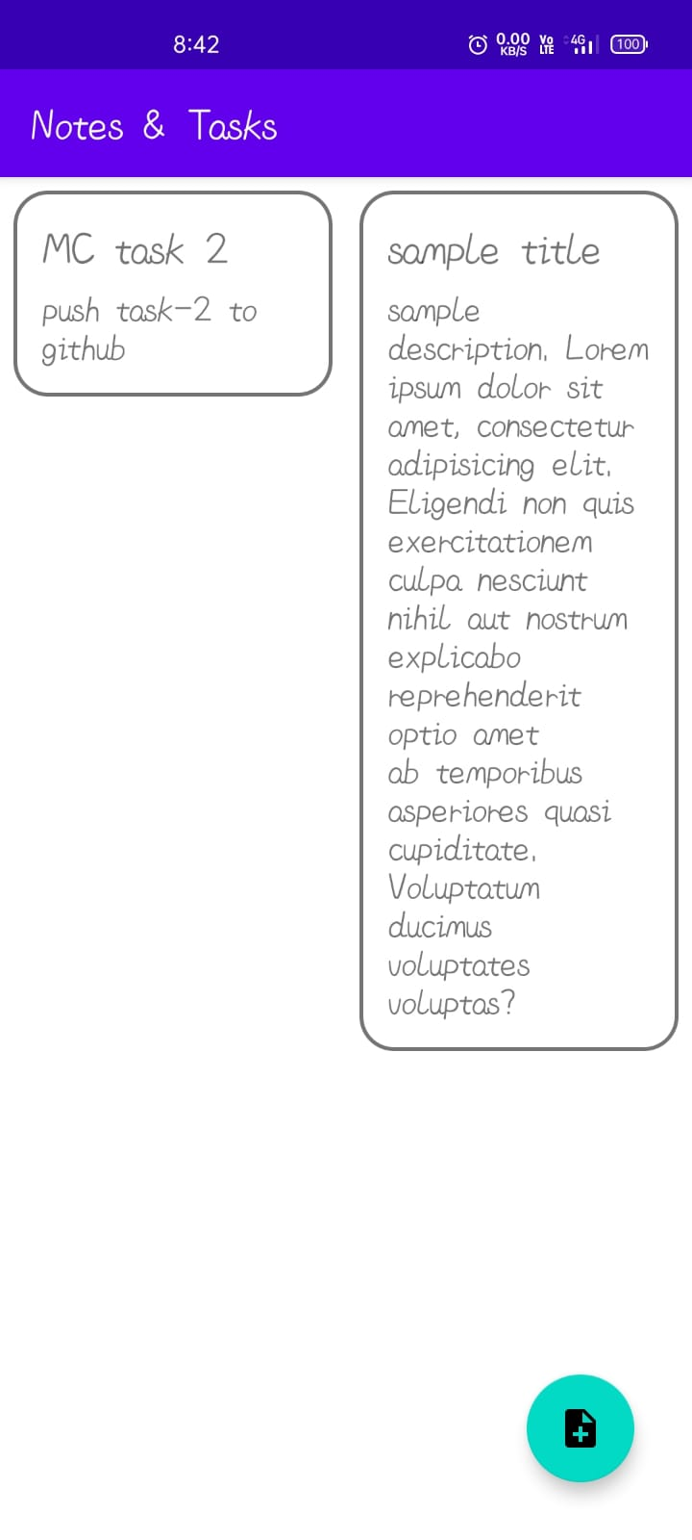

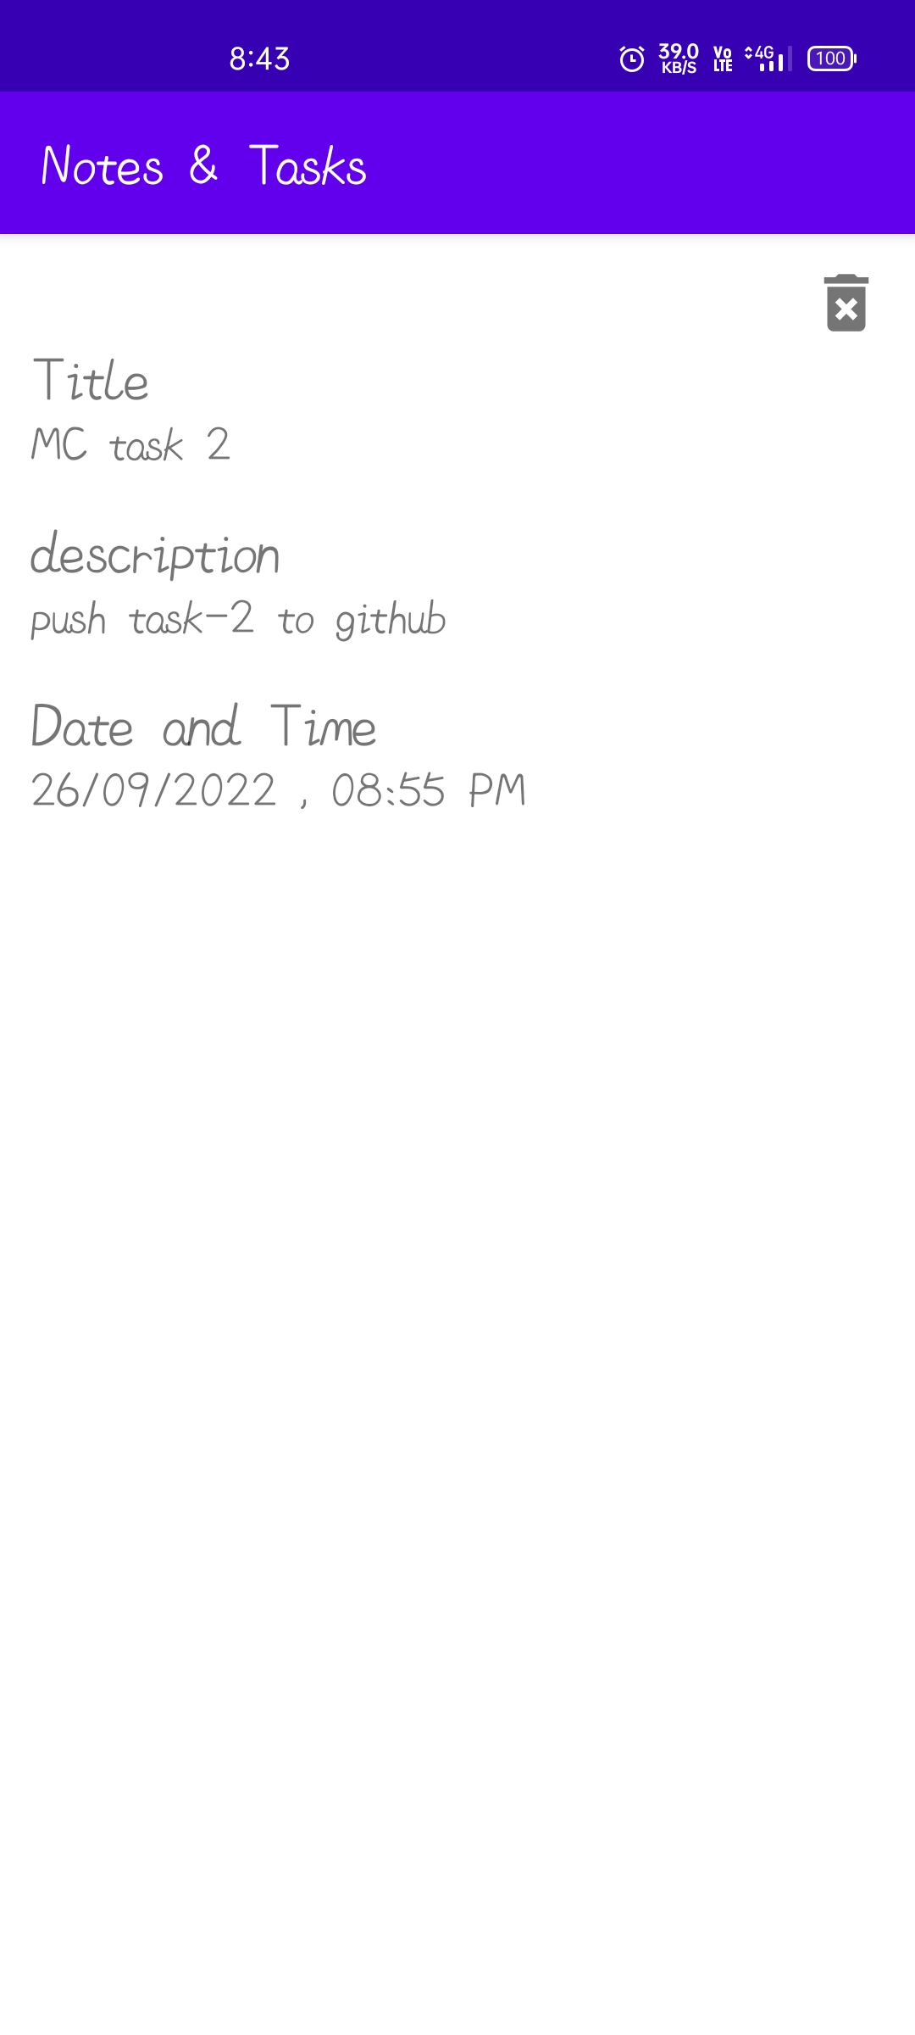

- FETURE SCOPE

We should expect to see an increase in note-taking gadgets in the classroom in various forms as note-taking technology grows more sophisticated with the addition of scribe pens and styli. We can see the possibility of transferring complicated material, such as handwritten text or drawings, digitally, with the rise of online,
hybrid, and blended learning courses. Tools outside of the notetaking realm are also taking up note-taking features. For example, eBooks are now using notetaking features such as annotating, highlighting, and underlining to mimic the experience of reading a physical book.

- CONCLUSION

From the research, we understood that, currently, the popularization of the internet has led to a decline in revenue in the paper industry, but the pen and pencil industry’s revenue has grown in recent years. These conflicting numbers are inconclusive in regard to whether or not students are abandoning paper-based notetaking. Many students are taking advantage of the electronics in the classroom. In conclusion, the major benefits of the project are:
- No reach limitations, it provides a user-friendly GUI which results in retaining of users.
- Lightweight Room Database.

- ACKNOWLADGEMENT

We hereby take the privilege of presenting our paper on the Android Notes Application. We are grateful to Ms. Niki Modi, our paper guide, for contributing and valuable time in the paper from their busy and hectic schedule. Thank you for looking after us like a true mentor and great academic parents.
We are very thankful to Ms. Niki Modi, whose guidance and support was an immense motivation for us to carry on with our paper. Also, suggestions have greatly contributed to the betterment of our paper.

- REFERENCES

[1] https://academictechnologies.it.miami.edu/explore-technologies/technology-summaries/note-taking-applications/index.html

[2] https://developer.android.com/docs

[3] https://developer.android.com/training/data-storage/room

[4]https://www.researchgate.net/publication/322250376_Affordances_of_mobile_devices_and_note-taking_apps_to_support_cognitively_demanding_note-taking

